The Power of Money in Football

Alex Wako

As the 2022-2023 winter transfer window approaches its end, the football world has seen a massive payout by Chelsea and the list of players they brought in. Considering the amount of money the new owners have, the expenditure was only a small means to improve their squad for current and future projects and boost their standing in the English Premier League. Nevertheless, the efforts to spend large sums of money to increase the firepower of the squad have shown that the footballing world is becoming more and more like an oligarchy where clubs with wealthy owners spend a bottomless amount of cash to win at all costs. Today, I want to look at the relationship between the spending of teams and their overall success in league competitions.

The reason I decided to compare teams within their own league, specifically the English Premier League, is because the money that teams get for playing in the league differs for each division and country. Additionally, tournament results for competitions such as the UEFA Champions League cannot compare to the lesser teams who do not receive as much funding as the top teams. These competitions put the top teams of each country into a knockout style tournament and having an advantage in team valuation cannot directly translate to wins and trophies. The purpose of this research is to find how wide the gap is between teams with money to teams without (if there is any), and the assumption is that money is not the only factor in earning victories.

The method I am proposing to find the relationship is through comparing the transfer spending of each window and comparing it to the results1. The variables to the relationship are:

* Team Name – The name of the football club.
* Window – The season of the transfer window. There is two possible data points: summer or winter.
* Season - The season the league was played. The data is from the 12-13 season all the way up to the first half of the 22-23 season.
* Expenditure – The amount of euros spent in millions. Each season is cumulative, so the winter transfer window will add onto the amount spent in the summer transfer window.
* Rank – The standing of the team in the league before the next transfer window.
* Matches Played – The number of matches played during the league season. The matches between the summer and winter windows are kept at matchday 18 for consistency. All data drawn from league tables considering the summer transfer window are data from matchday 18.
  + Win – The number of wins in the league season
  + Draw – The number of draws in the league season
  + Loss – The number of losses in the league season
  + Points – The number of points earned in the league season
  + Win Percent – The win percentage of team in the league season.

All data was found on Transfermarkt.com and premierleague.com and manually added into an excel sheet.

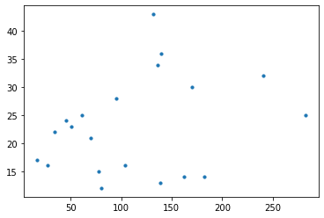 Using Python, I was able to create a scatterplot of the 22-23 season after the summer window. Just by a first glance, we can see that there isn’t really any strong linear correlation with transfer spending and result. The current first place team, Arsenal, spent less than 150 million and sit comfortably in first while the highest spending team, Chelsea, are far off from where they ideally want to be. Although a linear correlation does not seem to exist, a trend on the left-hand corner of the plot seems to be occurring. Teams that spend less have far less points compared to the league leaders, suggesting that money – although not at the top of the league – can secure teams a fair number of points. Exceptions exist, and West Ham and Nottingham Forest who are two of five teams that spent over 150 million euros during the 22-23 summer transfer window are battling to avoid relegation half-way through the season.